Course Title : Big Data Analytics
Course Code : Z1AMC 702
Name: Saumya Patel Registration No: 2511042210022

Experiment 4: Word Count of All Files Using Hadoop MapReduce
1) Objective
To perform a Word Count operation on multiple text files stored in HDFS using the Hadoop MapReduce framework and display the frequency of each word.

2) Procedure
Step 1: Create Input Text Files
Create multiple text files containing sample text data
file1.txt
Content for file one

file2.txt
Content for file two

file3.txt
Content for file three

Step 2: Verify the Files
ls -la file*.txt
Output: -rw-r--r-- 1 saumya saumya 21 Jun 18 02:47 file1.txt
-rw-r--r-- 1 saumya saumya 21 Jun 18 02:47 file2.txt
-rw-r--r-- 1 saumya saumya 23 Jun 18 02:47 file3.txt

Step 3: Create HDFS Input Directory

hdfs dfs -mkdir -p /saumya/$SAUMYA/hadoop_file/input

Step 4: Upload Files to HDFS

hdfs dfs -put *.txt /saumya/$SAUMYA/hadoop_file/input/

Step 5: Run the Word Count Program

hadoop jar $HADOOP_HOME/share/hadoop/mapreduce/hadoop-mapreduce-examples-*.jar wordcount \
/saumya/$SAUMYA/hadoop_file/input \
/saumya/$SAUMYA/hadoop_file/output
Step 6: View the Output

hdfs dfs -cat /saumya/$SAUMYA/hadoop_file/output/part-r-00000
Output:
Content 3
file 3
for 3
one 1
three 1
two 1

3) Source Code
hadoop jar $HADOOP_HOME/share/hadoop/mapreduce/hadoop-mapreduce-examples-*.jar wordcount input output

4) Screen Short
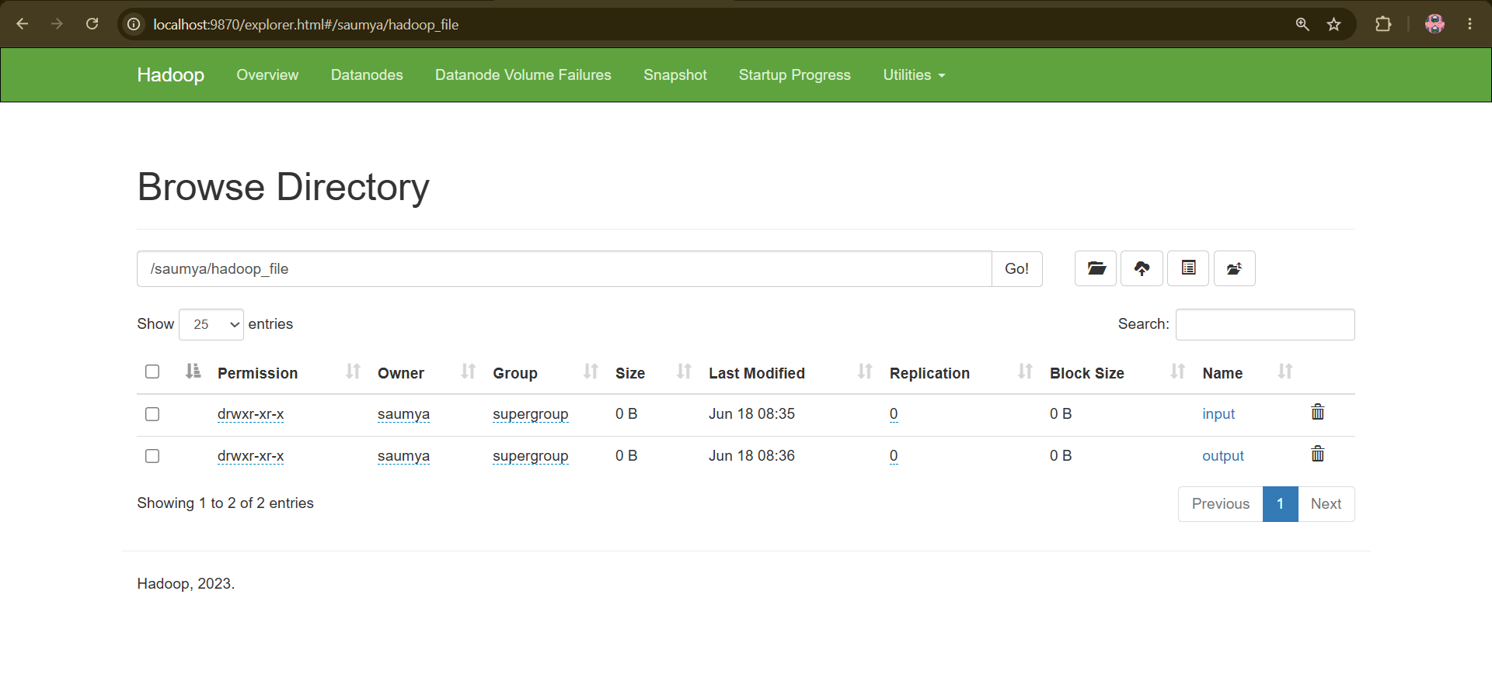

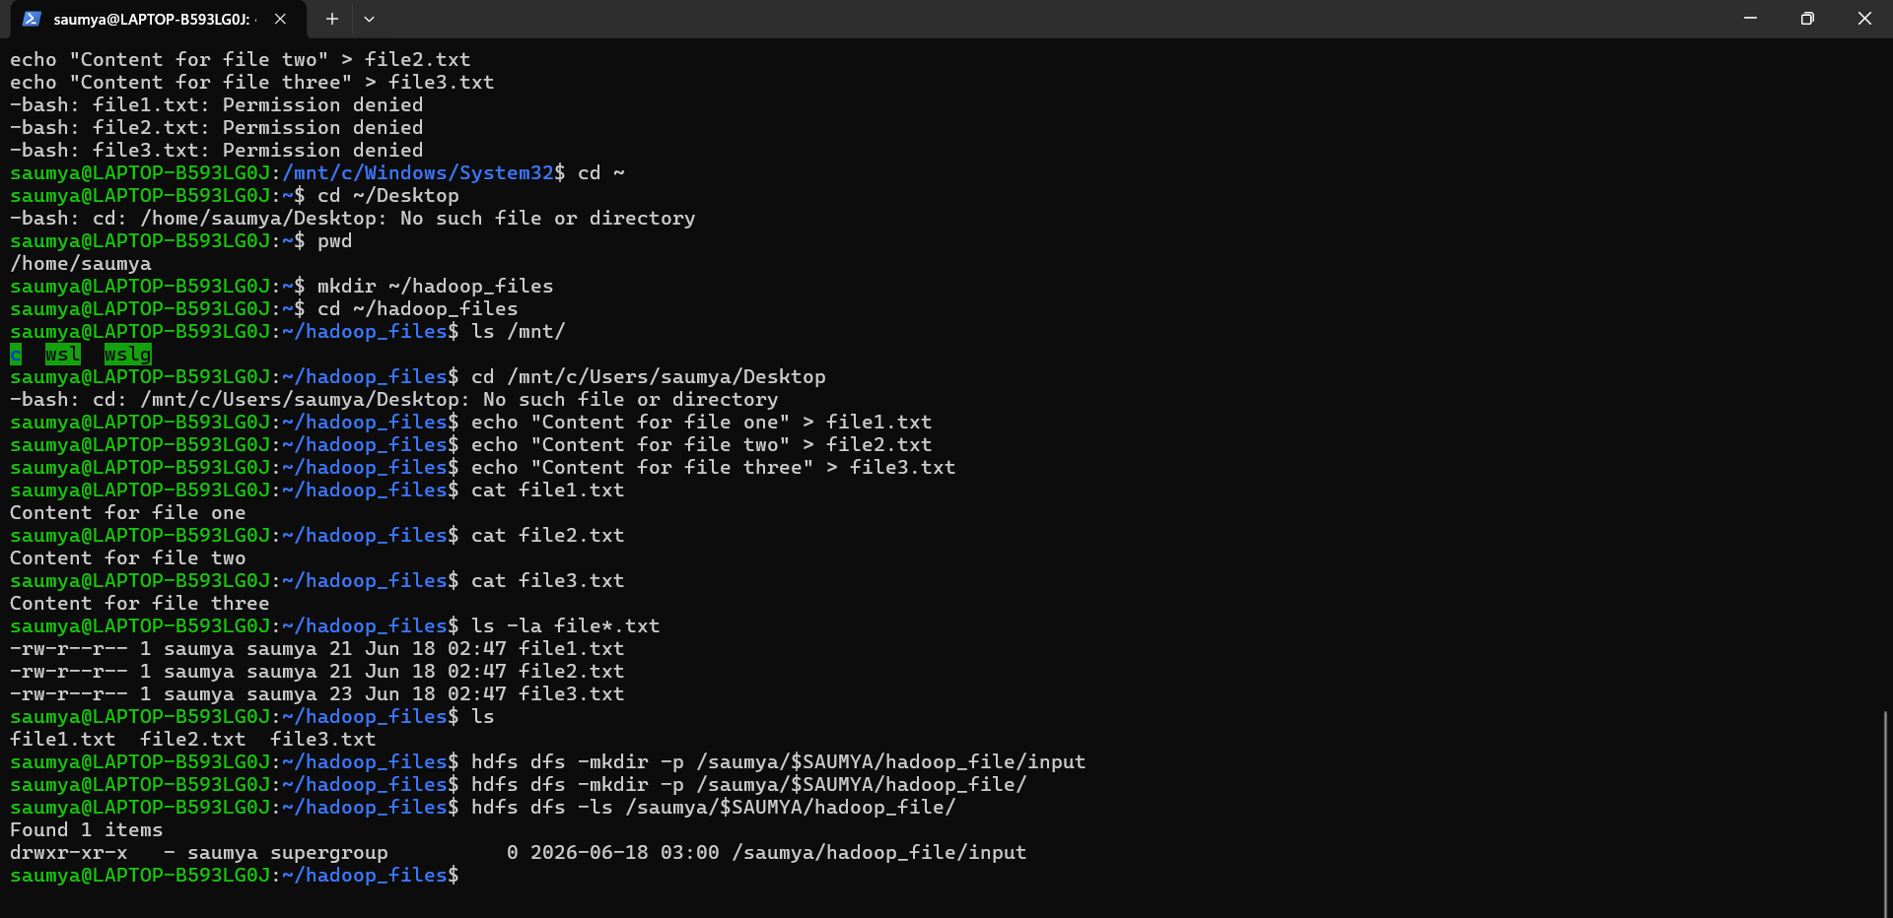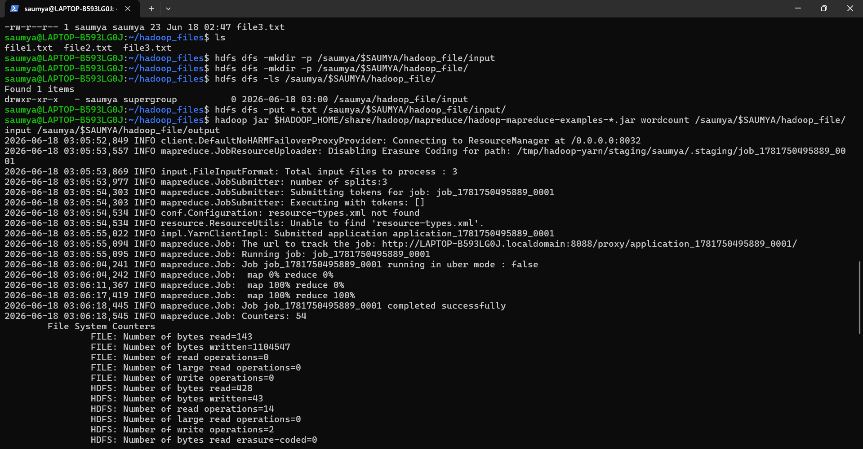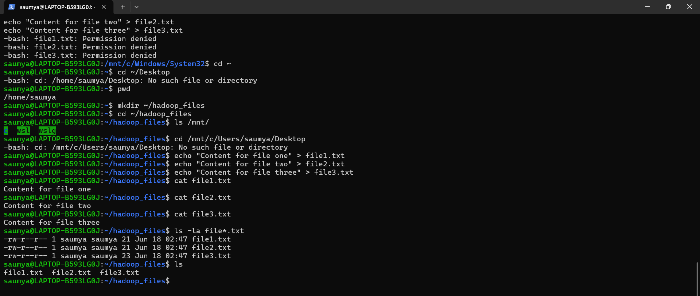
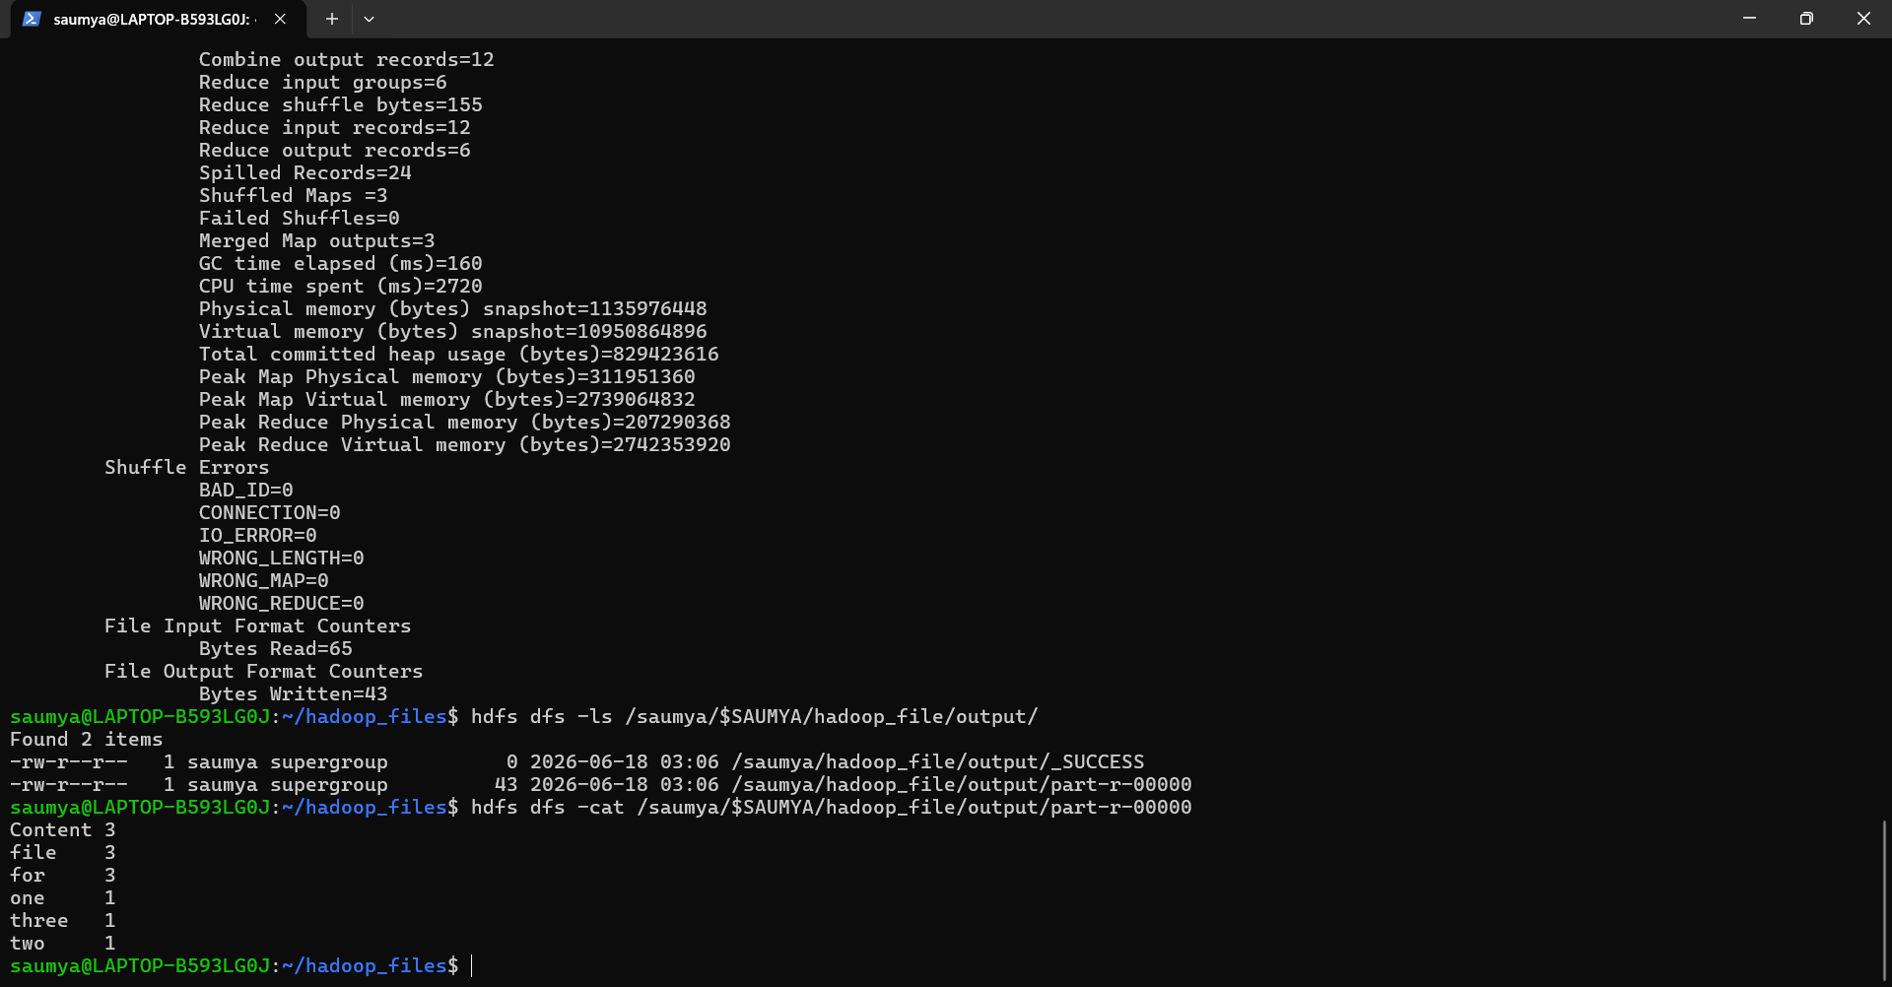
5) Conclusion
The Word Count MapReduce program was successfully executed on multiple text files stored in HDFS. Hadoop processed the files in a distributed manner and generated the frequency count of each word. The experiment demonstrated the working of the Map and Reduce phases and showed how Hadoop can efficiently process large datasets.

